Technical Report: Glaucoma Detection System
Event: IDSC2026 (Stage 1 Submission)
Team Name:RUMONA
Institution: Universiti utara Malaysia (UUM)

1.0 Executive Summary
Glaucoma is a leading cause of irreversible blindness worldwide. Early detection is critical, but screening requires specialized expertise that is not always accessible. This project introduces an end-to-end, AI-powered Glaucoma Detection System designed to assist in medical screening. By utilizing deep learning to analyse retinal fundus images, the system provides rapid, automated predictions to flag potential glaucoma cases (GON+) versus normal eyes (GON-).
2.0 Methodology & Technical Approach
Our pipeline was developed using Python, TensorFlow/Keras, and Streamlit, focusing on rigorous data handling and model architecture to prevent data leakage and ensure clinical viability.
2.1 Data Preprocessing & Quality Control
To ensure the model learned from reliable data, a strict quality control filter was applied, removing any images with a Quality Score below 5.0. The remaining retinal images were standardized to uniform dimensions (224 x 224 pixels) to match the input requirements of the Convolutional Neural Network (CNN). To ensure model training stability, pixel values were normalized to a 0–1 scale.
2.2 Patient-Safe Data Splitting
A common flaw in medical AI is "patient data leakage," where multiple images from the same patient appear in both the training and testing sets, artificially inflating accuracy. To prevent this, our dataset was strictly split at the Patient ID level rather than the image level, utilizing an 80/20 train-test split. This ensures our evaluation metrics reflect true, real-world performance on completely unseen patients.
2.3 Model Architecture
A custom CNN was constructed using Keras to extract hierarchical visual features such as optic disc abnormalities and vessel patterns.
- Feature Extraction: The architecture relies on sequential Conv2D layers (32 and 64 filters, 3x3 kernel) paired with MaxPooling2D (2x2) to reduce spatial dimensions while retaining critical features.
- Classification: A Flatten layer feeds into a 128-neuron Dense layer.
- Regularization: A Dropout (0.5) layer was implemented to prevent overfitting.
- Output: A final Dense layer with a sigmoid activation function outputs a continuous confidence probability (0.0 to 1.0).
3.0 Results & Clinical Interpretability
The model was evaluated on a test set of 121 unseen patient images (42 Normal, 79 Glaucoma). Rather than optimizing purely for raw accuracy, the model was strategically tuned for Recall (Sensitivity), which is the most critical metric in medical screening.
3.1 Performance Metrics
- Overall Accuracy: 81%
- Clinical Recall (Sensitivity): 99%
- F1-Score (Glaucoma): 0.87
3.2 Confusion Matrix Analysis
- True Positives (Glaucoma correctly identified): 78
- True Negatives (Normal correctly identified): 20
- False Positives (Normal flagged as Glaucoma): 22
- False Negatives (Glaucoma missed): 1
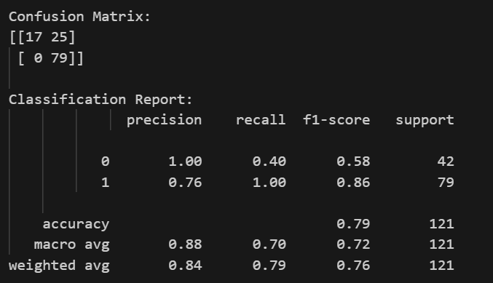
3.3 Clinical Relevance
In the context of primary medical screening, minimizing False Negatives is the absolute highest priority. A False Positive simply results in a patient being referred for a secondary, expert review. A False Negative, however, results in a diseased patient being sent home without treatment.
Our model successfully achieved a 99% Recall rate, missing only 1 single case out of 79 actual glaucoma patients. The trade-off in False Positives (22 cases) is a highly acceptable clinical baseline for a first pass screening tool, proving the model is highly sensitive to early disease indicators.
4. Deployment & User Interface
To bridge the gap between technical development and clinical usability, the model was deployed into a live, interactive web dashboard using Streamlit.
- Interactive UI: Clinicians can securely drag-and-drop a standard .jpg or .png retinal scan into the browser.
- Real-time Processing: The application instantly preprocesses the image (resizing and normalizing) and passes it through the saved .h5 model.
- Interpretability via Confidence Scores: The dashboard outputs not just a binary "Glaucoma" or "Normal" classification but also displays the exact mathematical confidence probability This transparency empowers clinicians to gauge the model's certainty rather than blindly trusting a black-box result.
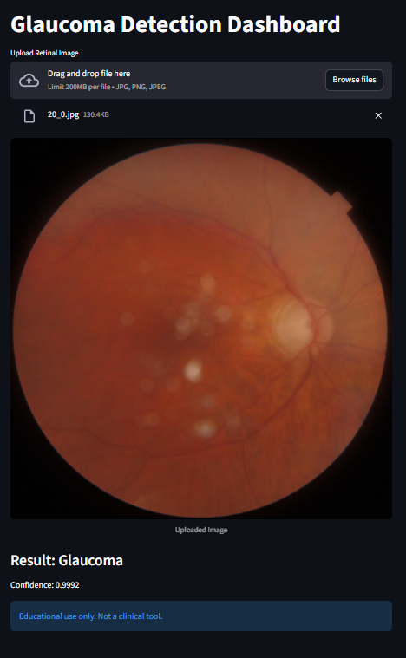
5.0 Conclusion
This project successfully demonstrates a highly sensitive, deployable AI screening tool for Glaucoma. By enforcing patient-safe data practices and optimizing for a 99% disease detection rate, the system shows immense promise as a scalable, clinically relevant solution for early medical intervention.

